|  |  |  |
| --- | --- | --- |
| Nama | : | Nur Syifa Maulida |
| NIM | : | 1207070088 |
| MatKul | : | PCD |

1. Interpolation

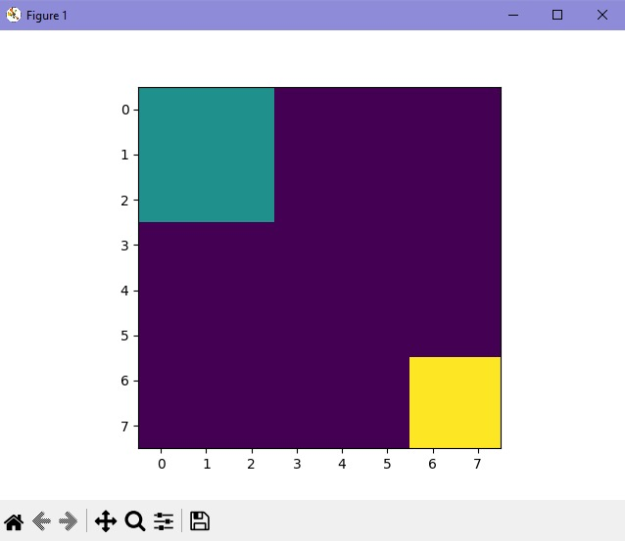

1. Filter Prewit

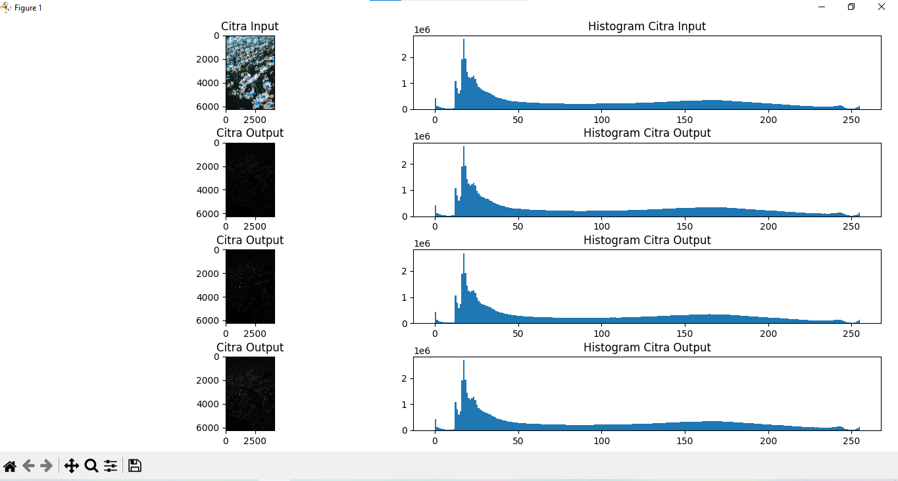

1. Transformasi Twirl

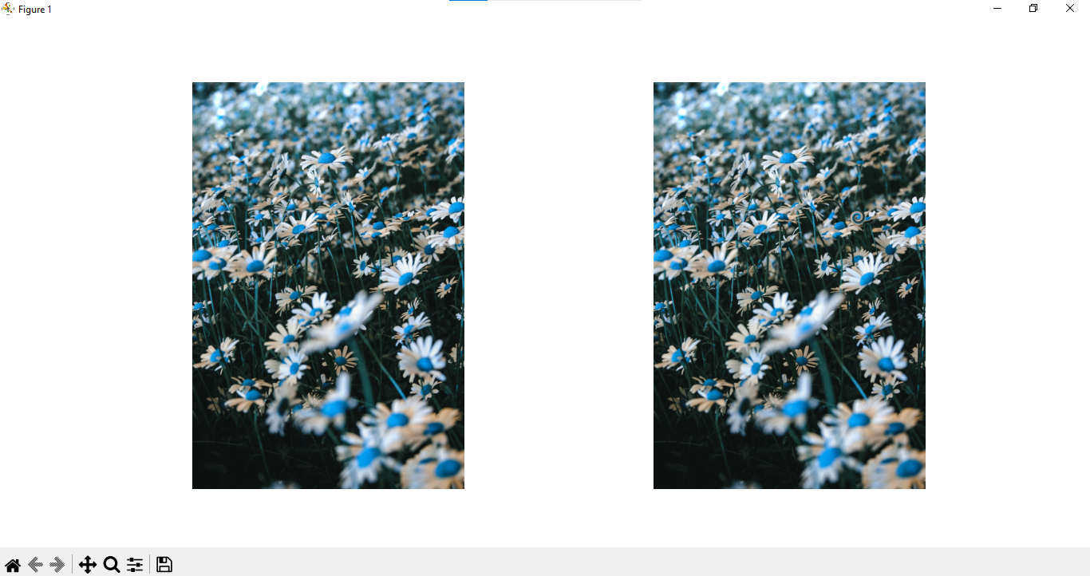

1. Translation

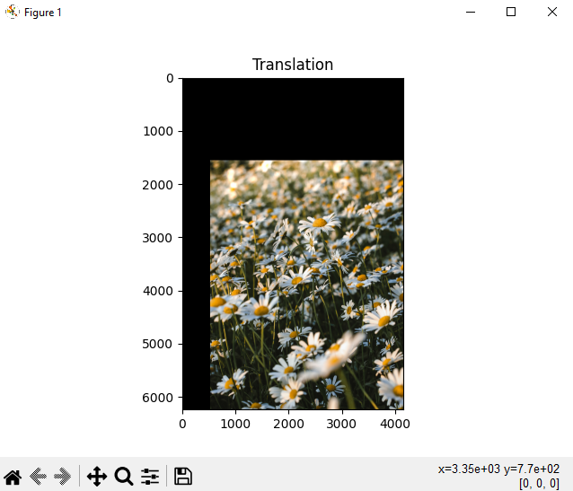

1. Skala Interpolasi Miring

